**Name: Session:**

**Programming I**

**Lab Exercise 11.15.2021**

**Making a PyGame Tic-Tac-Toe Board**

In today’s activity, you will make a Tic-Tac-Toe board using Pygame.

Your main program should look like this:

#initialize pygame

pygame.init()

#set counter to keep track of whose turn

turn = 0

#keep track of state of board - used to check who won

state = [[0,0,0], [0,0,0], [0,0,0]]

#set the drawing screen to 600 x 600

screen = pygame.display.set_mode([600,600])

pygame.display.set_caption("Tic-Tac_Toe")

#fill the screen with white

screen.fill([255, 255, 255])

#draw the lines for the tic-tac-toe board

drawLines()

#Create flag variable for ending game loop

quit = False

#Game loop

while not quit:

#Check all pygame events

for event in pygame.event.get():

#quit event

if event.type == pygame.QUIT:

pygame.display.quit()

sys.exit()

#KEYDOWN events

elif event.type == pygame.KEYDOWN

if event.key == pygame.K_c: #clear board event

resetState()

screen.fill((255, 255, 255))

drawLines()

turn = 0

elif event.key == pygame.K_s: #display the state of board

showState()

#MOUSEBUTTON event

elif event.type == pygame.MOUSEBUTTONDOWN:

if pygame.mouse.get_pressed() == (1, 0, 0):

#get position of mouse click and conver to list

pos = list(pygame.mouse.get_pos())

#Determine row and column selected

row = pos[1]//200

col = pos[0]//200

#Adjust x position to properly position X or O

if pos[0] < 200:

pos[0] = 20

elif pos[0] < 400:

pos[0] = 220

else:

pos[0] = 420

#Adjust y position to properly position X or O

if pos[1] < 200:

pos[1] = 20

elif pos[1] < 400:

pos[1] = 220

else:

pos[1] = 420

#update turn for next player

turn += 1

#Player turn

#draw X or O

#Update state array

#Check for win

if turn%2:

drawX(pos[0], pos[1])

state[row][col] = 1

if checkWin():

quit = True

else:

drawO(pos[0], pos[1])

state[row][col] = 2

if checkWin():

quit = True

#update display

pygame.display.flip()

time.sleep(4)

pygame.display.quit()

If you examine the starter code you will see that I have given you a function drawX which will draw an X at a specified location. You will need to create a drawO function that will draw an O at a specified location. The code for the drawO function is the same with the exception of the map of 1’s and 0’s which you will have to modify.

The window is 600 x 600. You will need to draw 4 lines that divide the window into equal thirds. You will then draw X’s and O’s at alternating locations as shown in the drawing above by calling the drawX(x,y) and drawO(x, y) functions.

In order to draw the lines for the game board, you should write a function drawLines as such:

def drawLines():

#Draw lines for Tic-Tac-Toe board

pygame.draw.line(screen, [0,0,0],[0,200], [600, 200])

pygame.draw.line(screen, [0,0,0],[0,400], [600, 400])

pygame.draw.line(screen, [0,0,0],[200,0], [200, 600])

pygame.draw.line(screen, [0,0,0],[400,0], [400, 600])

pygame.display.flip()

When you have completed your program, your tic-tac-toe board should look like this.

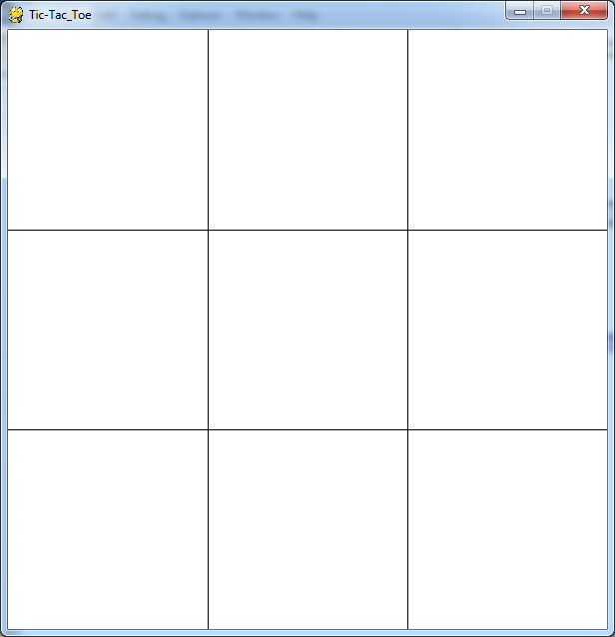

Once you have tested your program, and you get the above display, you will use the mouse to capture an (x, y) coordinate and draw and X or an O at that location.

Next we need to determine if someone has won the game. Your program has a list of lists (2D array) to keep track of the state of the board. In order to control things we will write 3 functions showState(), resetState(), and resetGame(). The showState() function is used during the development process for testing purposes. The resetState() function is used to reset the state array to all 0. It is called by resetGame() function. The resetGame() function resets the game to the starting state.

def showState():

#this function is used for testing

for i in range(3):

for j in range(3):

print(state[i][j], end = ' ')

print()

def resetState():

for i in range(3):

for j in range(3):

state[i][j] = 0

def resetGame():

resetState()

screen.fill((255, 255, 255))

drawLines()

turn = 0

quit = False

Next we need to determine who has won so we have a checkWin() function. In Tic-Tac-Toe, there are 8 ways to win. We have to check each row, each column and the 2 diagonals. The strategy we will use is that if any 3 cells in a row, column, or diagonal adds up to 3, then player 1 wins. If the sum is 6, then player 2 wins. I have given you the code to test column 1 (actually column 0 in CS terms). Your final working game should look like this:

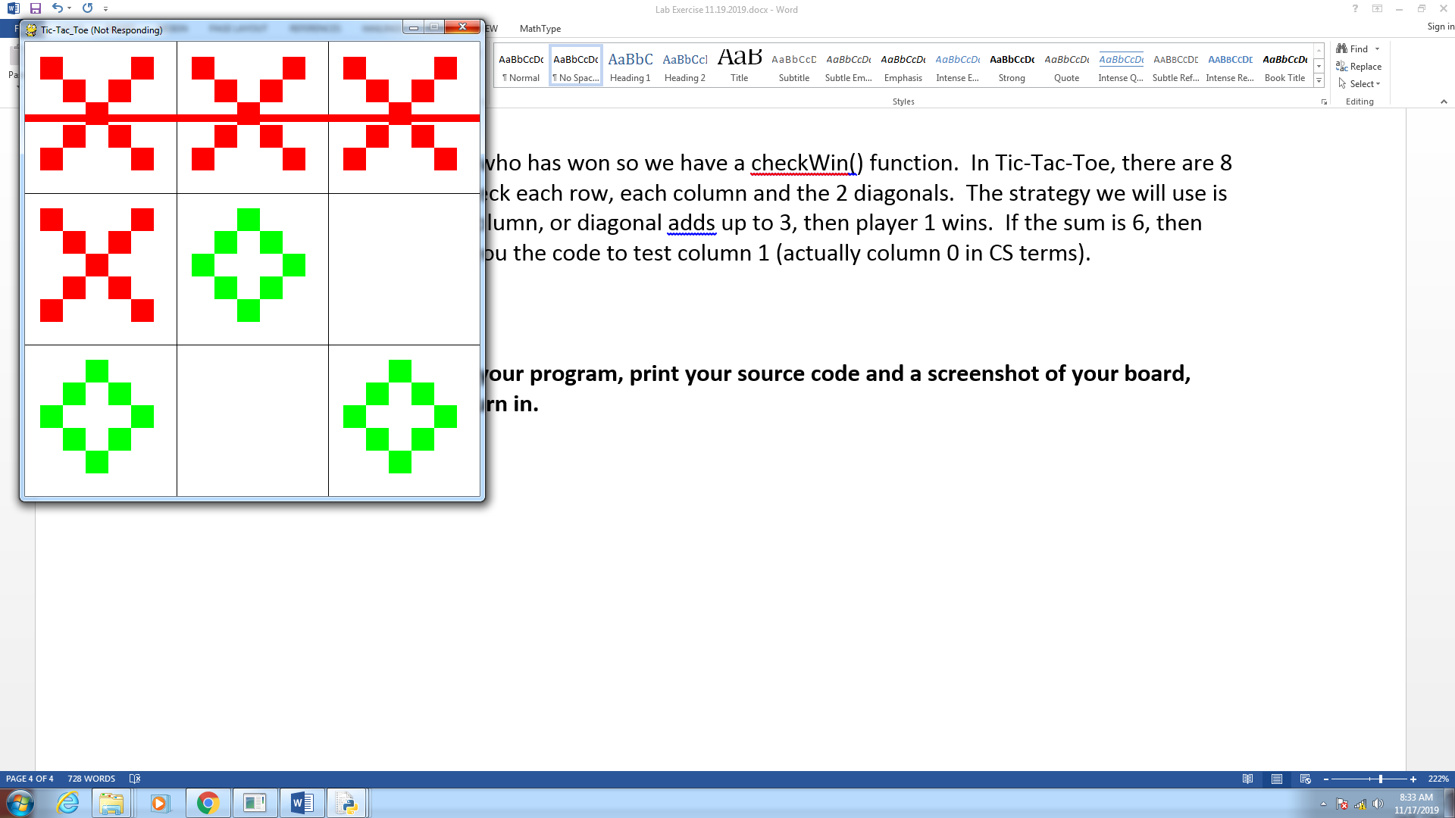

**When you have completed your program, print your source code and a screenshot of your board, attach it to this sheet and turn in.**